Date: 02/07/2026 Bash-Scripting-01

From Git Bash connect you server by using command
$ ssh -i "C:\Users\Pc\Downloads\keypair.pem" ec2-user@54.226.105.194
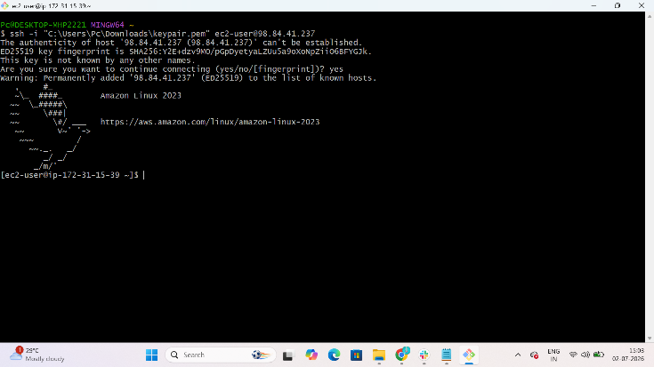

Create a new Separate Directory for bash scripting
$ mkdir -p /sarfaraz/scripts/
$ cd /sarfaraz/scripts/
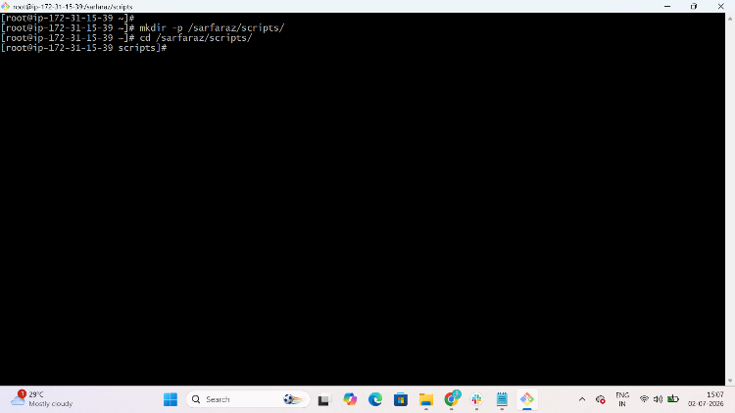
Create file: $ vi helloworld.bash
Give permission: chomd 755 helloworld.bash
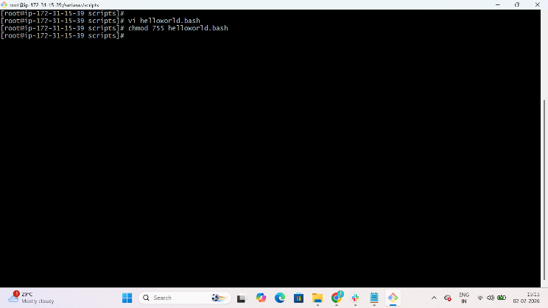

Write you Bash script in file
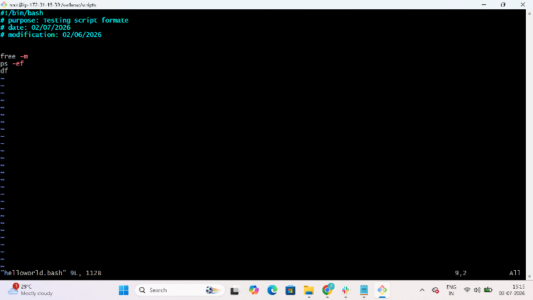

Execute Bash Script by using the command
$ ./helloworld.bash
Result;
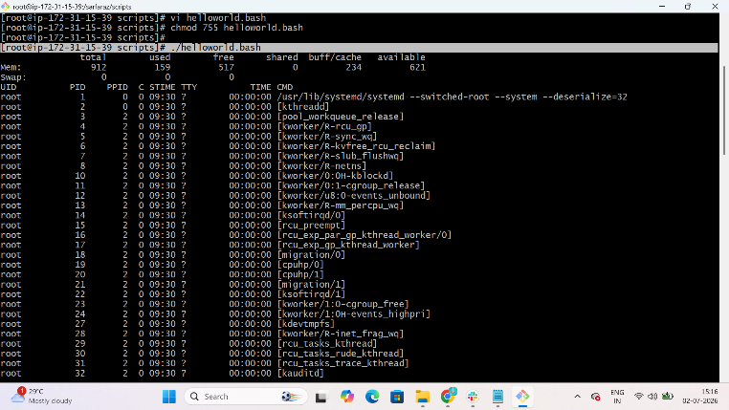
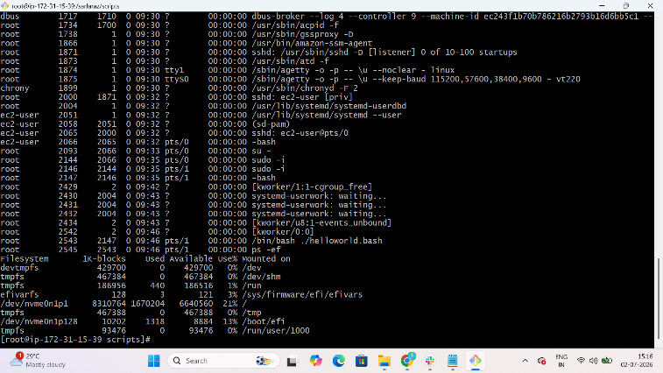

Create file: $ vi helloworld2.bash
Write you Bash script in file
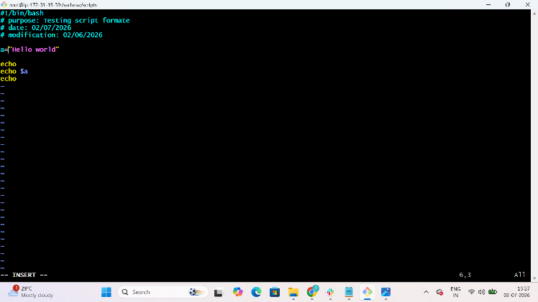

Give permission: $ chomd 755 helloworld2.bash
$ ./helloworld2.bash
Result;
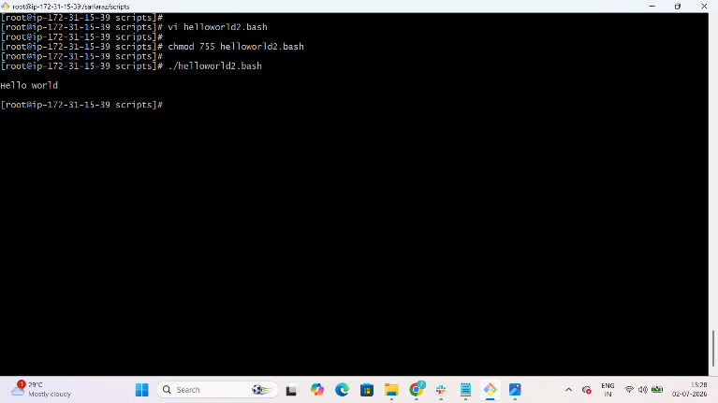

Create file: $ vi abc.bash
Write you Bash script in file
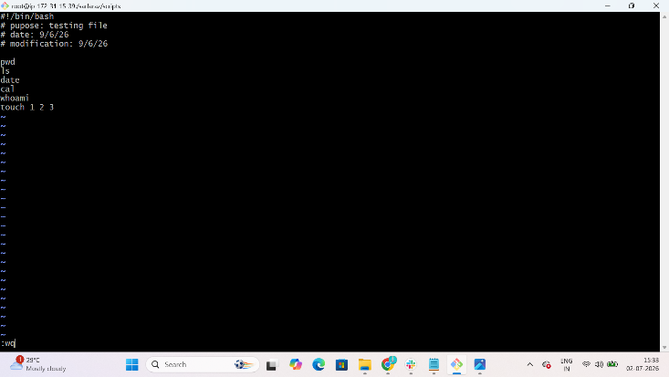

Give permission: chomd 755 abc.bash
$ ./abc.bash
Result;
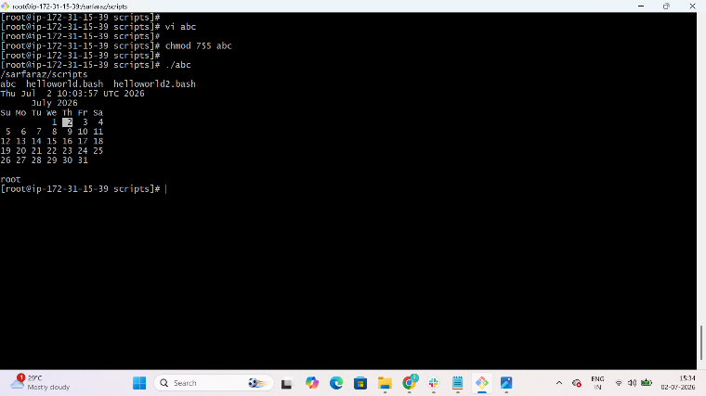

Create file: $ vi admin.bash
Write you Bash script in file
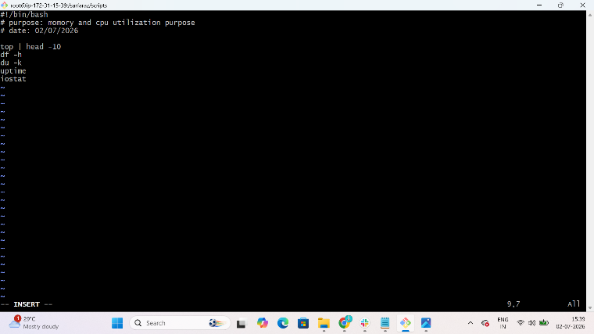
Give permission: chomd 755 admin.bash
$ ./admin.bash
Result;
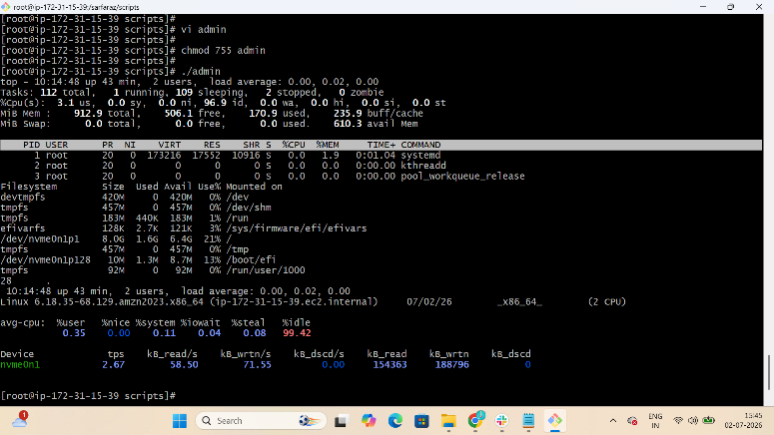

Create file: $ vi input.bash
Write you Bash script in file
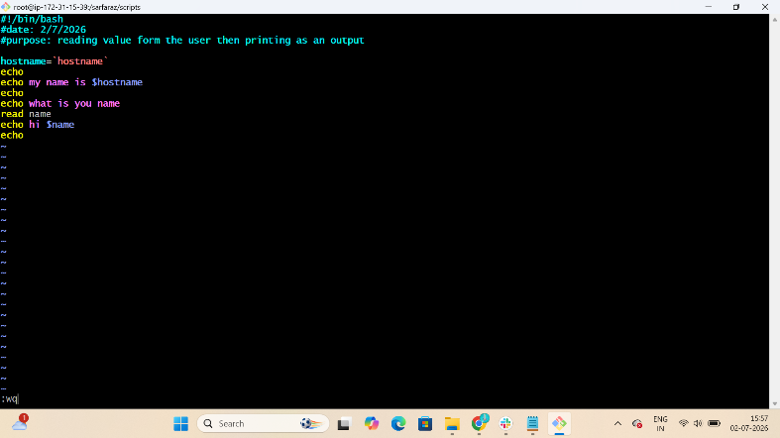
Give permission: chomd 755 input.bash
$ ./input.bash
Result;
